Eg: Remove_Duplicates_From_2Files_To_Form_Unique_Elements_InResult

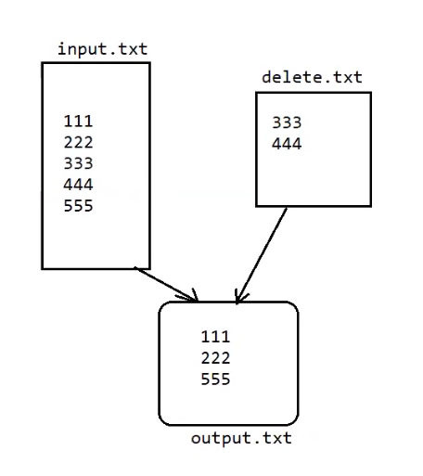

Eg: Highest_No_Of_Characters_String_In_File

// go through the code